**CHAPTER 1**

**INTRODUCTION**

The Rural Outreach Program is designed to uplift rural communities by addressing key issues such as health awareness, environmental sustainability, skill development, and heritage tourism promotion. The program is structured to empower rural populations through education, technology, and sustainable practices while ensuring active community participation. By integrating innovative approaches, research-driven strategies, and professional values, the outreach program has made a significant impact in different domains of rural development. One of the primary initiatives under this program is the promotion of tourism at Someshwar Temple in Laxmeshwar. This historical temple, with its rich cultural heritage, has untapped tourism potential. Infrastructure enhancements, digital initiatives, and sustainable development strategies have been implemented to attract visitors and boost local engagement. By leveraging technology, such as AR-based guides, digital booking systems, and live-streaming of temple rituals, the temple has gained greater visibility among tourists. Another crucial component of the program is environmental conservation through tree plantation and public encourages tree planting in rural areas. The awareness drives educate villagers on the long-term benefits of awareness campaigns. Given the increasing deforestation and environmental degradation, this initiative afforestation, including improved air quality, reduced soil erosion, and climate resilience. Sustainable best practices such as rainwater harvesting and organic farming techniques are also promoted to ensure long-term ecological balance. The agriculture-focused activity under this program aims to train rural farmers on the effective use of cow dung in farming. Cow dung, a traditional yet underutilized resource, enhances soil fertility, increases crop yield, and promotes organic farming practices. Through interactive workshops and demonstration farms, villagers are educated on its proper utilization, including its role in composting and bio-fertilizer production. This initiative not only improves agricultural productivity but also promotes sustainable rural livelihoods. Healthcare awareness is another critical pillar of the program. The health and disease awareness campaign educates rural populations on preventable diseases, hygiene, nutrition, and vaccination. Many rural communities lack access to medical facilities and have limited knowledge about basic health practices. This program bridges the gap by conducting free medical camps, telemedicine services, and mobile health.

**CHAPTER 2**

**Activity 1 :**

**Plantation And Adoption of trees**

**1.1 Overview**: Fig is very delicious fruit like tread and popularly known as ``anjeer`` in india, fig is mostly confined to part of Gujarat Maharashtra, UP, Tamilnadu and Karnataka, fig can grow to more than 2.4m tall in only three month and start bearing fruits, there are 21 popular varieties fig that are being cultivated in the world, in India `poona` is the most popular variety, most of the fig fruit grown in daulatabad the Poona fig, in recent days a variety called `dinkar` improvement over 'daulatabad' variety the yield and fruit quality is gaining commercial important.

Description: The word 'fig' usually refers to Ficus, the fig tree and its fruit known as the Common fig (Ficus carica). The Common fig is a large, deciduous shrub or small tree native to southwestern Asia and the eastern Mediterranean region (Greece east to Afghanistan). It grows to a height of 3–10 m, with smooth gray bark

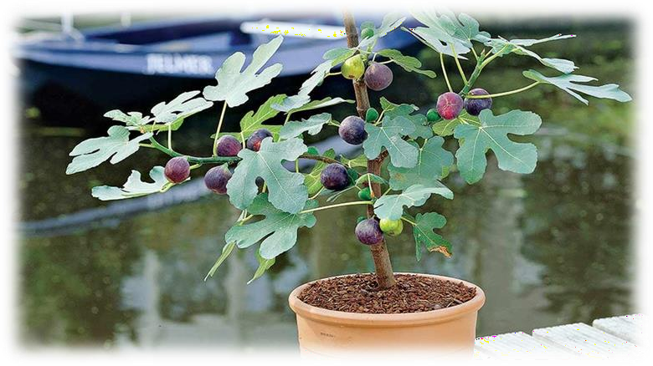

**1.2 Use of Technology:**

The word 'fig' usually refers to Ficus, the fig tree and its fruit known as the Common fig (Ficus carica). The Common fig is a large, deciduous shrub or small tree native to southwestern Asia and the eastern Mediterranean region (Greece east to Afghanistan). It grows to a height of 3–10 m, with smooth gray bark

**1.3 Sustainable Development best practices:**

Fig favours areas having arid or semi-arid environment, high summer temperature, plenty of sunshine and moderate winter. The plant has better threshold limit for higher temperature than for the lower. Although plants can survive temperature as high as 45°C, the fruit quality deteriorates beyond 39°C. Mature trees can withstand temperature up to 4°C, but young ones need protection. Climate has an important bearing on size, shape and colour of skin and pulp. A relatively cool climate stimulates production of larger and elongated fruits.

**1.4 Sustainable Development best practices**

The fruit and leaves are used to make medicine. Fig fruit is used as a laxative to relieve constipation. Fig LEAF is used for diabetes, high cholesterol, and skin conditions such as eczema, psoriasis, and vitiligo. Figs are also used as a quick and healthy way to gain weight after suffering from an illness.

## Parts of fig tree:

* **Leafs:** Fig leaves, botanically classified as Ficus carica, grow on a deciduous tree or shrub and are members of the Moraceae, or mulberry family. Known for its fleshy fruits, fig trees thrive in warm and dry climates and can grow to be 3-9 meters in height.
* **Fruit:** Figs are a unique fruit resembling a teardrop. They're about the size of your thumb, filled with hundreds of tiny seeds, and have an edible purple or green peel. The flesh of the fruit is pink and has a mild, sweet taste. The scientific name for the fig is Ficus carica.
* **Roots:** Figs are a shallow fibrous rooted species, although depending on location, the roots may spread laterally and vertically. Figs may have a single stemmed tree like growth or multi-stemmed shrub-like growth and often send up suckers from the base of the tree and spreading branches that are low to the ground.
* **Seeds:** A cluster of many flowers and seeds contained inside a bulbous stem. Because of this unusual arrangement, the seeds—technically the ovaries of the fig— require a specialized pollinator that is adapted to navigate within these confined quarters.

**Activity 2 :**

**Heritage Walk and Crafts Corner**

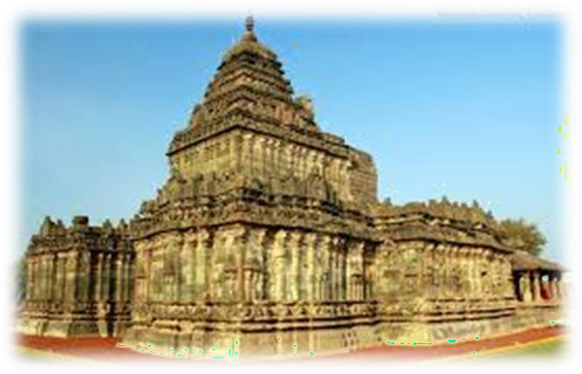**2.1 Overview:**

Trikuteshwar Temple, Tanga Koot, Gadag, Karnataka 582103 Trikuteshwar Temple is located at Tanga Koot, Gadag, Karnataka and 420 kms from Bangalore.Gadag, a prosperous town of importance in Dharwad district of Karnataka, was known in the ancient days by various names, as Kratuka, Kratupura, Ka rdugu, Galadugu and Gadagu. It was also known as ‗Maha Agrahara‘. One of the inscriptions found in the region mentions that Gadag was a part of Belavola, a country comprising of the fertile tract surrounding Dambal, Gadag and Lakkundi. The political history of Gadag has been varied. The Rashtrakutas, the later Chalukyas, the Yadavas of Devagiri and the Vijayanagar kings were successive suzerains of this region

The Trikuteshwar temple which is also called ‗Swayambhu Ishwara‘.

‗Tripurusha‘.‗Swayambhu Trikuteshwar‘ is built in 1002 A.D. This is of Kalyana Chalukya Architecture and Chalukya, Hoysala, Vijayanagara dyanasties gave importance to the development of this temple. Facing to the East, Trikuteshwara stands in the garbhagriha. This is explained as swayambhu Brahma, Vishnu, Maheshwaras‘ replica in the ‗Kruthapura Mahathme‘.

**2.2 Use of Technology:**

This temple was built around 1050 to 1200, during the reign of the Western Chalukyas. It was designed and built by the acclaimed architect Jakanachari. The main shrine has three Shiva Lingas representing the Trimurthis Brahma, Shiva and Vishnu. The other shrine is dedicated to the Goddess of Learning, Saraswathi. Decoratively carved walls and pillars, wall panels with beautifully sculpted figures, and stonework screens make this temple very attractive.

The main shrine has the three Lingas representing the Trinity on a single base. Pujas are still offered here. Sadly, the Saraswathi idol has been damaged at some period by vandals and so it is not used. Even while broken, the statue is still remarkable and leaves you wondering how beautiful it would have looked when whole. In an adjacent temple, there are three shrines.

The temples of Trikuteshwara and Saraswati are in the same compound. The Trikuteshwara temple is bigger. In reality, it is a double shrine with two separate ‗sanctums‘ facing each other. The bigger shrine is on the western side and faces east. To this is attached the smaller closed ‗mandapa‘. The bigger ‗mandappa‘ is connectedwith the smaller shrine on the east. In between these ‗mandapas‘, there is a narrow passage with doors leading to north and south. The northern exit leads into a smaller attached shrine. This appears to be a later addition. The other exit opens into the courtyard in the south.

The temple dates back[citation needed] to the Kalyani Chalukyas who ruled this region from around 1050 to 1200 CE, during which time about 50 temples were built. Saraswathi temple has been vandalised in the early age and hence pooja is not offered here. But the architecture is exists.

A number of late Chalukya monuments (11th-12th centuries) in the city indicate its historic past. Other temples in Gadag are those dedicated to Someshwara and Veera Narayana. In the middle of the city stands the Someshvara Temple. Though abandoned and now in a dilapidated state, its intricate carvings are preserved. The doorways to the hall have densely carved figures and foliation.

**2.3 Sustainable Development best practices:**

Trikuteshwara Temple architecture was planned by the architect Amara Shilpi Jakanachari. The Badami Chalukyas were exponents of early architectural achievements in Deccan. Aihole, Badami, and Pattadakal were their centers of art. They were succeeded by the Rashtrakutas and the Kalyani Chalukyas.

The temples of Trikuteshwara and Saraswati Trikuteshwara temple is bigger. In reality, it is a double shrine with two separate ‗sanctums‘ facing each other. The bigger shrine is on the western side and faces east. To this is attached the smaller closed

mandapa‘. The bigger ‗mandappa‘ is connected with the smaller shrine on the east. In between these ‗mandapas‘, there is a narrow passage with doors leading to north and south. The northern exit leads into a smaller attached shrine. This appears to be a later addition.The other exit opens into the courtyard in thesouth.

The visible portion of the larger ‗mandapa‘ on the exterior is intricatelycarved. The decoration consists of scrolls with small perforations in alternate squares and rows. In the niches of the walls are idols, among others, of Bhairava, Lakshmi, Vishnu, Ganapati, Shiva, Narasimha, Mahishamardini, etc.

The ‗vimana‘ (spire) of the temple is a later addition in brick and plaster. The Nandi‘ on the front is also made by these materials. Successive coats of white wash have almost entirely obliterated the fine tracery upon the doorway of the temple.

Just by the side is another temple dedicated to three devices – Saraswathi, Gayathri, and Sharada. Only the statues are in a new style; the temple is in old architecture. The temple dates back to the Kalyani Chalukyas who ruled this region from around 1050 to 1200 CE, during which time about 50 temples were built. Saraswathi temple has been vandalized at an early age and hence poojais not offered here. But the architecture exists. A new temple has been built for Goddess Saraswati under the advice of Shankaracharya, Kanchipuram. Temple Timings are 07:00 AM– 12:30 PM | 05:00 PM – 08:30 PM

**Activity 3 :**

**Organic Farming And Wet Waste Management**

**3.1 Overview:**

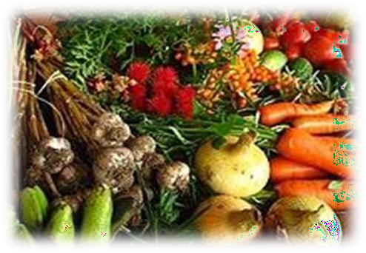Organic farming, also known as ecological farming or biological farming, is an agricultural system that uses fertilizers of organic origin such as compost manure, green manure,and bone meal and places emphasis on techniques such as crop rotation and companion planting. It originated early in the 20th century in reaction to rapidly changing farming practices. Certified organic agriculture accounts for 70 million hectares (170 million acres) globally, with over half of that total in Australia. Organic farming continues to be developed by various organizations today. Biological pest control, mixed cropping and the fostering of insect predators are encouraged. Organic standards are designed to allow the use of naturally-occurring substances while prohibiting or strictly limiting synthetic substances. For instance, naturally-occurring pesticides such as pyrethrin are permitted, while synthetic fertilizers and pesticides are generally prohibited. Synthetic substances that are allowed include, for example, copper sulfate, elemental sulfur and Ivermectin. Genetically modified organisms, nanomaterials, human sewage sludge, plant growth regulators, hormones, and antibiotic use in livestock husbandry are prohibited. Organic farming advocates claim advantages in sustainability, openness, self- sufficiency, autonomy and independence, health, food security.

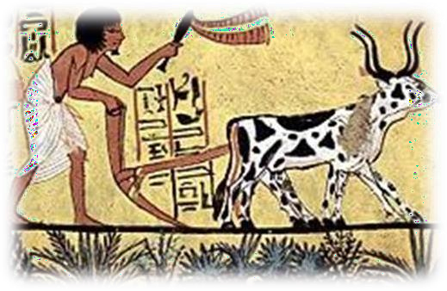

Organic agricultural methods are internationally regulated and legally enforced by many nations, based in large part on the standards set by the International Federation of Organic Agriculture Movements (IFOAM), an international umbrella organization for organic farming organizations established in 1972. Organic agriculture can be defined as "an integrated farming system that strives for sustainability, the enhancement of soil fertility and biological diversity while, with rare exceptions, prohibiting synthetic pesticides, antibiotics, synthetic fertilizers, genetically modified organisms, and growth hormones". Since 1990, the market for organic food and other products has grown rapidly, reaching$63 billion worldwide in 2012. This demand has driven a similar increase in organically- managed farmland that grew from 2001 to 2011 at a compounding rate of 8.9% per annum. As of 2020, approximately 75,000,000 hectares (190,000,000 acres) worldwide were farmed organically, representing approximately 1.6% of total world farmland Organic farming can be beneficial on biodiversity and environmental protection at local level. However, because organic farming has lower yields compared to conventional farming, additional agricultural land is needed elsewhere in the world.

**3.2 Use of Technology:**

## Agriculture was practiced for thousands of years without the use of artificial chemicals. Artificial fertilizers were first developed during the mid-19th century.

## These early fertilizers were cheap, powerful, and easy to transport in bulk. Similar advances occurred in chemical pesticides in the 1940s, leading to the decade being referred to as the 'pesticide era'. These new agricultural techniques, while beneficial in the short- term, had serious longer-term side-effects such as soil compaction, erosion, and declines in overall soil fertility, along with health concerns about toxic chemicals entering the food supply. In the late 1800s and early 1900s, soil biology scientists began to seek ways to remedy these side effects while still maintaining higher production.

The use of "organic" popularized by Howard and Rodale refers more narrowly to the use of organic matter derived from plant compost and animal manures to improve the humus content of soils, grounded in the work of early soil scientists who developed what was then called "humus farming". Since the early 1940s the two camps have tended to merge.

**3.3 Sustainable Development best practices:**

Organic farming methods combine scientific knowledge of ecology and some modern technology with traditional farming practices based on naturally occurring biological processes. Organic farming methods are studied in the field of agroecology. While conventional agriculture uses synthetic pesticides and water-soluble synthetically purified fertilizers, organic farmers are restricted by regulations to using natural pesticidesand fertilizers. An example of a natural pesticide is pyrethrin, which is found naturally in the Chrysanthemum flower. The principal methods of organic farming include crop rotation, green manures and compost, biological pest control, and mechanical cultivation.These measures use the natural environment to enhance agricultural productivity: legumesare planted to fix nitrogen into the soil, natural insect predators are encouraged, crops arerotated to confuse pests and renew soil, and natural materials such as potassium bicarbonate and mulches are used to control disease and weeds. Genetically modified seeds and animals are excluded.

**Activity 4**

## Wet Waste Management

**4.1 Introduction:**

Waste management is an important issue that needs to be addressed in order to maintaina healthy and sustainable environment. Wet waste management is an integral part of waste management, as it involves the proper management of liquid or semi-liquid waste material. Wet waste can include food waste, sewage, and other liquids, and can be a source of water pollution if not managed properly. The proper management of wet waste is essential for both environmental and public health reasons. This report will discuss the various methods of wet waste management and their associated benefits and drawbacks.

**4.2 Use of Technology:**

Wet waste is defined as any liquid or semi- liquid material that is generated from humanactivities. It can include food waste, sewage, wastewater, and industrial liquids. Wet waste can be a source of water pollution if not managed properly, as it contains a variety of pollutants and microorganisms that can contaminate water sources. The proper management of wet waste is essential for both environmental and public health reasons.

There are several methods of wet waste management that can be used to reduce the impact of wet waste on the environment. These methods are:

* Sewage treatment
* Composting
* Land application
* Incineration.

**Sewage treatment:**

Sewage treatment is a method of wet waste management that involves the treatment ofwastewater to remove pollutants and bacteria. This process typically involves the use of physical, chemical, and biological treatments to remove contaminants and reduce the pollutionload of the wastewater. The treated wastewater can then be safely discharged into surface waterbodies or reused.

**4.3 Sustainable Development best practices:**

Composting is a method of wet waste management that involves the breakdown of organic materials, such as food waste, into a nutrient-rich soil amendment. Composting can used to reduce the amount of waste sent to landfills and also be used to improve soil quality.

**Land application:**

Land application is a method of wet waste management that involves the spreading of sewage sludge and other liquid waste materials on land for agricultural or landscaping purposes. This method of wet waste management can be beneficial, as it can help to improve soil fertility and reduce the amount of waste sent to landfills.

**Incineration:**

Incineration is a method of wet waste management that involves the burning of wet waste materials to reduce their volume. This method can be beneficial, as it reduces the amount of waste sent to landfills and can also be used to generate energy. However, incineration also releases pollutants into the atmosphere, so it should only be used when other methods are not feasible.

## Benefits of wet-waste management:

The proper management of wet waste can provide numerous benefits to both the environment and public health. Some of the benefits of wet waste management include:

**Reduced Pollution:** Proper management of wet waste can help to reduce water pollutionby removing pollutants from wastewater before it is discharged into surface water bodies.

**Reduced Waste:** Proper management of wet waste can help to reduce the amount of waste sent to landfills, which can help to conserve resources and reduce the environmental impact of landfills.

**Improved Soil Quality:** Wet waste management methods such as composting and land application can help to improve soil quality by introducing organic materials and nutrients intothe soil.

**Improved Public Health:** Proper management of wet waste can help to reduce the risk of water-borne diseases, as wastewater is treated to remove contaminants and bacteria before it is discharged into surface water bodies.

**Activity 5 :**

## Water Conservation

**5.1 Overview:**

Water, Paani, Jal, Tanni, L‘eau, Wasser, Acqua perhaps the most familiar and widely used word in the world. Water needs no introduction, the importance of this is known to one and all. However, despite water being the basic human need, this precious resource is being wasted, polluted and getting depleted. Every drop of water is precious but we continue to waste it like it is a free natural commodity. 98% of water on this planet is salty and is not fit for human consumption. Out of the 2% of fresh water reserves, 1% is locked up in form of ice in various regions around the world. Hence, only 1% of total water reserves are available for our domestic & industrial use. Many cities in India and around the world are already facing sever water shortages due to reduced rainfall, man-made climatic changes, reduction in ground water levels, population explosion, industrialization and staggering amount of water wastages because of negligence by users & dilapidated water supply systems. The importance of water in a country‘s economic growth should not be undermined.

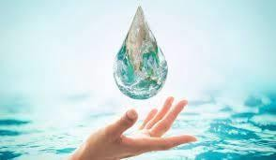

Water pollution, unavailability of drinking water, inadequate sanitation, open dumping of wastes, loss of forest cover are some of the problems faced by many parts of India. Heavy toll of infant mortality due to water borne diseases, the daily struggle for procuring water, mismanagement of waste water, improper sanitation are common features and are leading to 76 serious consequences on human health and the economy of the country. The situation demands immediate intervention in the management of these rapidly growing problems, especially through an integrated approach for water, sanitation and related issues.

**5.2 Use of Technology:**

## The Aims of water conservation efforts include: With less than 1% of the world‘s water being freshwater, one aim is ensuring the availability of water for future generations where the withdrawal of freshwater from an ecosystem does not exceed its natural replacement rate.

Energy conservation as water pumping, delivery, and wastewater treatment facilities consume a significant amount of energy. In some regions of the world, over 15% of the total electricity consumption is devoted to water management. Habitat conservation where minimizing human water usage helps to preserve freshwater habitats for local wildlife and migrating 22aterfowl, but also water quality.

## Conservation:

Water conservation can be defined as:

* Any beneficial deduction in water loss, use, or waste.
* A reduction in water use accomplished by implementation of water conservation or water efficiency measures; or,
* Improved water management practices that reduce or enhance the beneficial use of water a water conservation measure is an action, behavioral change, device, technology, or improved design or process implemented to reduce water loss, waste, or use. Water efficiency is a tool of water conservation. That results in more efficient water use and thus reduces water demand. The value and cost-effectiveness of a water efficiency measure must be evaluated in relation to its effects on the use and cost of other natural resources.(e.g. energy or chemicals)

## Strategies:

## The key activities to conserve water are as follows:

Any beneficial reduction in water loss, use and waste of resources.Avoiding any damage to water quality.Improving water management practices that reduce the use or enhance the beneficial use of water. One of the strategies in water conservation is rain water harvesting.Digging ponds, lakes, canals, expanding the water reservoir, and installing rain water catching ducts and filtration systems on homes are different methods of harvesting rain water. Many people in many countries keep clean containers so they can boil it and drink it, which is useful to supply water to the needy. Harvested and filtered rain water can be used for toilets, home gardening, lawn irrigation, and small scale agriculture

Another strategy in water conservation is protecting groundwater resources. When precipitation occurs, some infiltrates the soil and goes underground.Water in this saturation zone is called groundwater. Contamination of groundwater causes the groundwater water supply to not be able to be used as a resource of fresh drinking water and the natural regeneration of contaminated groundwater can take years to replenish.Some examples of potential sources of groundwater contamination include storage tanks, septic systems, uncontrolled hazardous waste, landfills, atmospheric contaminants, chemicals, and road salts. Contamination of groundwater decreases the replenishment of available freshwater so taking preventative measures by protecting groundwater resources from contamination is an important aspect of water conservation

**5.3 Sustainable Development best practices:**

Drip irrigation system in New Mexico Water conservation programs involved in social solutions are typically initiated at the local level, by either municipal water utilities or regional governments. Common strategies include public outreach campaigns, tiered water rates (charging progressively higher prices as water use increases), or restrictions on outdoor water use such as lawn watering and car washing. Cities in dry climates often require or encourage the installation of xeriscaping or natural landscaping in new homes to reduce outdoor water usage. Most urban outdoor water use in California is residential, illustrating a reason for outreach to households as well as businesses.

One fundamental conservation goal is universal water metering. The prevalence of residential water metering varies significantly worldwide. Recent studies have estimated that water supplies are metered in less than 30% of UK households. Although individual water meters have often been considered impractical in homes with private wells or in multifamily buildings, the US Environmental Protection Agency estimates that metering alone can reduce consumption by 20 to 40 percent. In addition to raising consumer awareness of their water use, metering is also an important way to identify and localize water leakage. Water metering might benefit society by providing a financial incentive to avoid waste in water use. Some researchers have suggested that water conservation efforts should be primarily directed at farmers, in light of the fact that crop irrigation accounts for 70% of the world‘s fresh water use. The agricultural sector of most countries is important both economically and politically, and water subsidies are common. Conservation advocates have urged removal of all subsidies to force farmers to grow more water-efficient crops and adopt less wasteful irrigation techniques.

New technology poses a few new options for consumers; features such as full flush and half flush when using a toilet are trying to make a difference in water consumption and waste. It is also possible to use/‖pollute‖ the water in stages (keeping use in flush toilets for last), hereby allowing more use of the water for various tasks within a same cycle (before it needs to be purified again, which can also be done in-situ). Earth ships often use such a setup.

**CHAPTER 3**

**3.1 Innovative Approaches Taken**

To effectively spread awareness, several innovative approaches were implemented. Interactive educational sessions using visual aids and storytelling methods made complex health topics easier to understand. Digital health awareness campaigns reached even remote populations through mobile applications and SMS alerts. Additionally, partnerships with local schools helped educate children about hygiene and disease prevention, encouraging them to act as change agents within their families.

**3.2 Research Done**

Before launching the program, extensive research was conducted to identify the most prevalent health issues in rural communities. Surveys and interviews were carried out to assess knowledge gaps and community concerns. Studies on successful health awareness programs in other rural areas provided insights into best practices. Government health data and reports were also analyzed to ensure alignment with national health initiatives.

**3.3 Knowledge and Understanding Gained**

Through this initiative, a deeper understanding of rural healthcare challenges was gained. It became evident that a lack of knowledge, combined with traditional misconceptions about health, contributed to the spread of preventable diseases. The importance of using simple, relatable language in health education was recognized, as well as the need to provide practical solutions that could be easily adopted by the local population.

**3.4 Professional Values and Best Practices Incorporated**

The program adhered to professional ethics and best practices, ensuring respect for cultural beliefs while promoting evidence-based healthcare. Transparency was maintained in all interactions, and feedback mechanisms were established to address concerns. Inclusivity was prioritized, ensuring that women, elderly individuals, and marginalized groups received equal access to healthcare information and services

**3.5 Areas for Further Development**

Although the initiative was successful, there are several areas for improvement. Expanding the program to include mental health awareness is crucial, as psychological well-being is often overlooked in rural areas. Strengthening collaboration with local healthcare providers can improve follow-up care for individuals.

**3.6 Challenges and Solutions**

* **Low Literacy Levels:** Many individuals struggled to understand written health materials. This was addressed by using pictorial representations and audio-based educational tools.
* **Resistance to Modern Medicine:** Some community members preferred traditional remedies over scientifically proven treatments. Awareness sessions included discussions on integrating traditional medicine with modern healthcare approaches.
* **Limited Access to Healthcare Facilities:** The lack of nearby medical centers was a challenge. Mobile health camps were introduced to provide on-the-spot check-ups and consultations.
* **Misinformation about Diseases:** Rumors and myths about diseases like COVID-19 and vaccinations created fear. A dedicated myth-busting campaign was launched, providing factual, research-based information.

**3.7 Feedback and Continuous Improvement**

Regular feedback was collected through community meetings and anonymous surveys to gauge the effectiveness of the program. Suggestions from healthcare professionals, volunteers, and residents were analyzed to refine the awareness strategies. As a continuous improvement measure, refresher sessions were planned every six months to keep the community informed about new health challenges and advancements in medicine.

Through these efforts, the rural outreach program successfully increased awareness about health and diseases, making a lasting impact on the well-being of the community.

**CHAPTER 4: Documentation of Activities**

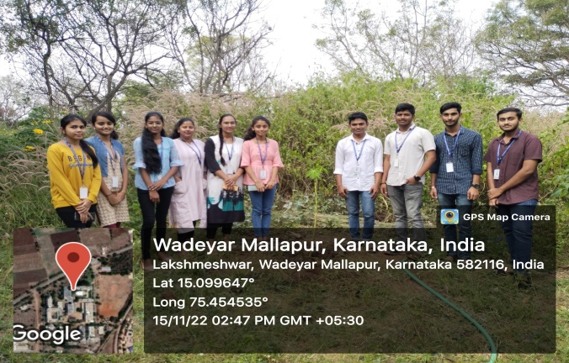**Activity 1 : Plantation And Adoption of trees**

Fig 1: Plantation And Adoption of trees

**Activity 2 : Heritage Walk and Crafts Corner**

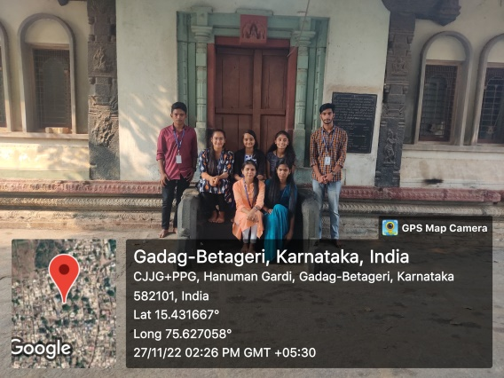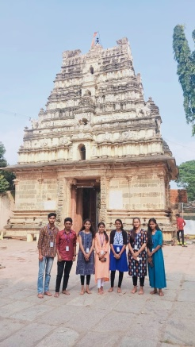

Fig 2: Heritage Walk and Crafts Corner

**Activity 3 : Organic Farming**

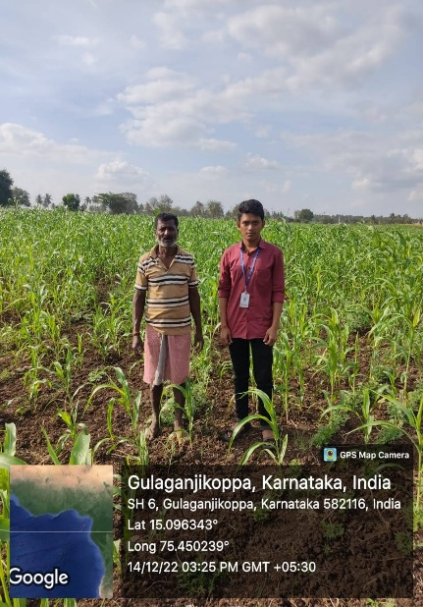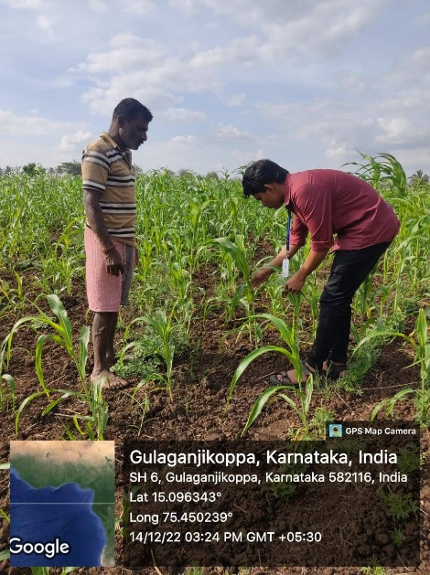

Fig 3: Organic Farming

**Activity 4 : Wet Waste Management Activity**

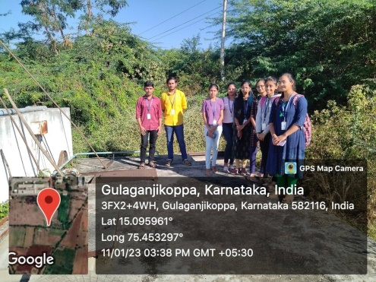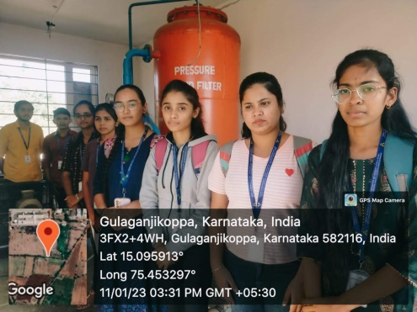

**Fig 4: Wet Waste Management**

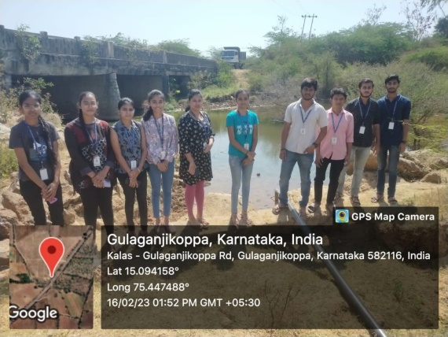**5 : Water Conservation**

**Fig 5: Water Conservation**

**Hampi Heritage Trip**

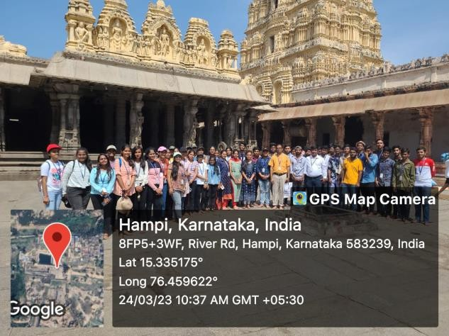

## 

## 

## 

## CHAPTER 5

## Conclusion

The Rural Outreach Program has successfully contributed to the upliftment of rural communities through a multidimensional approach focused on environmental sustainability, skill development, healthcare awareness, tourism promotion, and agricultural advancements. By implementing innovative methods such as digital initiatives, interactive educational sessions, and community-driven projects, the program has empowered local populations and fostered sustainable development.

The various activities—ranging from tree plantation and organic farming to heritage walks and wet waste management—have addressed critical socio-economic and environmental concerns. Moreover, collaboration with local stakeholders has enhanced community participation, ensuring the long-term impact of these initiatives.

While significant progress has been made, challenges such as low literacy levels, resistance to modern healthcare, and limited access to facilities highlight the need for continuous engagement and refinement of strategies. Expanding the program to cover mental health awareness, strengthening partnerships with healthcare providers, and incorporating more technology-driven solutions can further improve outreach efforts.

The success of this initiative underscores the importance of integrating traditional wisdom with modern solutions to create a sustainable and resilient rural ecosystem. Future efforts should build upon the learnings from this program to extend its reach and effectiveness, ensuring continued benefits for rural communities.

### ****References****

1. **Rural Development & Outreach Programs**
   * Government of India, Ministry of Rural Development. (Latest Reports on Rural Development Programs). Available at: https://rural.nic.in
2. **Tourism & Heritage Conservation**
   * UNESCO World Heritage Centre. (Heritage Site Preservation & Sustainable Tourism)*.* Available at: <https://whc.unesco.org>
3. **Environmental Conservation & Tree Plantation**
   * Food and Agriculture Organization (FAO). (Sustainable Forestry & Tree Plantation)*.* Available at: <https://www.fao.org>
4. **Organic Farming & Agricultural Sustainability**
   * International Federation of Organic Agriculture Movements (IFOAM). (Organic Farming Standards & Practices)*.* Available at: <https://www.ifoam.bio>
5. **Waste Management & Sustainability**
   * United Nations Environment Programme (UNEP). (Guidelines on Wet Waste Management)*.* Available at: <https://www.unep.org>
6. **Water Conservation & Management**
   * Central Water Commission, India.(Water Conservation Policies & Reports)*.* Available at: <http://www.cwc.gov.in>
7. **Healthcare & Disease Awareness in Rural Areas**
   * World Health Organization (WHO*).* (Public Health & Disease Prevention in Rural Areas). Available at: <https://www.who.int>